Pressures of Being Biracial

Rush hour. Tokyo’s streets rumble. Businessmen and women race through stations, passing by various ads. One featuring Grand Slam tennis champion Naomi Osaka plays on rows of electronic pillars. Few people look. Commuters hurry to catch the next train.

Trains roar throughout the city. Inside them, people scroll through their phones. Between stops, mute ads and news updates appear on the train’s small tv screen just above the automatic sliding doors. One reports NBA star Rui Hachimura being traded to the Lakers. Some passengers look at the screen, their eyes widen, then turn back to their phones. Exhausted straphangers fight their sleepiness. They want to be home.

Osaka and Lakers forward Rui Hachimura are two world class athletes. Their faces are plastered across cities and inside train stations, and they flash across people’s television screens at home, too, in commercials for Panasonic, Shiseido, ANA, MasterCard, Nike, Jordan Brand, Beats, Nissin, and much more. Osaka and Hachimura have contracts with companies that use their image to sell products all over the world, and that includes Japan. The two have one other thing in common: They are each part Japanese. However, all the exposure also brings out hate comments or mono-racial views towards them.

Part-Japanese does not always mean that a person will be held in great esteem by the Japanese. In fact, there is a distinct strain of race-purity thinking in Japan that often brings out an ugly side of the national character. In 2019, the food company Nissin aired a now infamous anime style ad in Japan that literally whitewashed Osaka, and turned her into a racially ambiguous person of a very light skin color. In the same year, Osaka also promoted Shiseido’s sunscreen line, “Anessa” but she was soon attacked by a pair of Japanese comedians who said Osaka was “too sunburned” and “needed bleach.” Even speaking out against racial discrimination, promoting the Black Lives Movement, and encouraging her followers to participate in the rally prompted backlash from Japanese people since Osaka got involved in politics. Japanese companies also became wary on how to promote her.

Marketing student at Temple University, Sayo Fujita, identifies the differences in Osaka’s portrayal between Western and Japanese ads, highlighting that Nike showcases Osaka’s actual personality by not giving her scripts and keeping commercials simple whereas Japanese marketers like Shiseido try to portray Osaka as quiet and shy since “it has high marketability in Japan, but, Japanese people find ‘Japanese-ness’ in her behavior or words really often.”

Fujita gave two major reasons why Osaka is generally popular among brands: she is a symbol for women’s empowerment and she has great political influence, especially regarding racial issues. Though, the latter is taken unfavorably in Japan and Fujita explains that “Japanese companies don’t want to focus on her political activities. They make scripts and those kinds of things to use her in the way they want to. But in that sense, they can’t really show her positivity because it’s so superficial.” But even if Japanese companies try altering Osaka’s image to suit their audiences, there’s always people that challenge her identity.

Two years later, some Japanese Internet trolls and an Australian journalist questioned her “Japanese-ness” after she was chosen to be the torchbearer for the 2021 Summer Olympics that were held in Tokyo. (Ironically, in the Netflix documentary on Osaka and her career, she revealed how people on social media revoked her “black card” for not adequately representing America in Tokyo that year).

Seemingly, many biracial individuals are caught in a constant struggle between two communities, never able to fully appease both sides. According to scholar Miri Song, multiracial people might face “prejudice and forms of racial hostility” from both of their communities. This harassment and treatment signify that the individual is not fully accepted in one mono-racial community and could lead to a “heightened awareness or concern about racial identification and belonging.”

Hachimura has faced similar racial problems in Japan. In 2021 when Hachimura’s younger brother, Aren, tweeted about being discriminated against in Japan, Rui replied, pointing out how he too faces similar racial hate almost daily. The frequency with which Japanese question or attack the identity of those of mixed race is shocking, especially when you take into consideration Japan’s long history of talented biracial achievers in many fields.

In the late 1960s and early 70s, right after the US Occupation in Japan during WWII, there was a spike in biracial Japanese babies, most of them children of Japanese women and American soldiers. By the late 60s, these babies had reached their mid-teens or early 20s, and mixed-race stars like Linda Yamamoto, the singer and model, and Bibari Maeda, an actress who is also part American and part Japanese, were familiar faces to the Japanese. According to independent scholar, Hyoue Okamura, Japanese movie magazine, Kindai eiga (Modern Movies) called this era the “mixed-blood talent boom.” Many of these early biracial celebrities were part Caucasian, but some were half Black, usually with fathers who had also been American servicemen.

Singer and actress Michi Aoyama (Black and Japanese) came into public view in Japan with her powerful enka-blues performances. Aoyama — along with several other Black-Japanese celebrities — was also featured in the September 1967 issue of the premier U.S. Black magazine Ebony. “Japan’s Rejected:,” the cover headline read, over photos of eight mixed-race adolescents. “Teen-age war babies face bleak future.” A stigma targeting Black-Japanese was evidently prevalent, especially towards an ordinary mixed person, but it’s important to note that negative articles towards mixed celebrities were rare.

Okamura (who emphasizes more on the racial obsession of “haafu-sa” [ハーフさ half-ness] in his article) briefly mentions representations of multiracial Japanese in the Japanese media after

World War II, writing that “racially-mixed personalities in Japan, most of whom are Japanese citizens, have generally been featured as part of the country’s ‘natural fauna’ so to speak. Racially negative articles are rare.” Because of the growth in number of its mixed-race population, Japan started granting certain official recognition to its most famous multiracial citizens.

The Japanese government featured vocalist Fujiwara Yoshie, born from a Japanese geisha and biwa-player and a Scottish merchant, and artist Isamu Noguchi, son of a Japanese poet and a Caucasian American writer based in Los Angeles, on their stamps in 1998 and 2004. Mixed race athletes also have received official recognition, and some have been given what’s known as the “People’s Honor Award,” this includes baseball players Oh Sadaharu (part Chinese part Japanese) in 1977 and then Kinugasa Sachio (part African American part Japanese) in 1987. Since the end of WWII, Japanese culture and society have illuminated the most talented of their biracial citizens with the spotlight of celebrity.

Yet, most mixed-race people were only adored and celebrated if they were famous (or in many cases, part Caucasian). Many biracial people grew up facing discrimination in their early and high school lives, especially if they looked differently from other Japanese. Until the development of social media where people could more easily spread their discriminatory experiences to a wider audience, perspectives on mixed Japanese would barely change in everyday life.

Journalist Isabella Silvers interviewed 2016’s Miss Japan, Priyanka Yoshikawa, for her Substack newsletter, “Mixed Messages.” In her early years, Yoshikawa, who is half Indian and grew up in Japan and in Sacramento, California, says she felt isolated. “While there were some mixed TV personalities,” she told Silvers, “they weren’t the same as me. I felt like we were on different planets; they were on TV, I was being bullied in school.” Once she started using the internet, Yoshikawa says, she felt better. “TikTok, Instagram and YouTube are helping so much,” she said. “It’s easier to feel related to people. I’ve seen biracial people comment that Naomi Osaka has shown them hope for living in Japan.”

Osaka — alongside several other mixed Japanese figures — has been an inspiration for mixed people across Japan after addressing the challenges she faced and the messages she conveys for other mixed people. Over the course of multiple interviews, Osaka has iterated that she is not fluent in the language and doesn’t like replying in it, yet the Japanese media frequently ask Osaka to reply in Japanese (although, most of the audience supports Osaka and critiques the Japanese media for always forcing her to answer in Japanese). She told ESPN she wants Japanese society to understand people don’t have to look or speak the language to be Japanese. She questions, “How do people categorize being a nationality?” Especially when people have Japanese blood in their veins.

Rui’s experiences overlap with many Black-Japanese kids growing up in the countryside or smaller neighborhoods. The NBA athlete expressed how he tried hiding from people when he was in public and said in an interview for the Olympics that "in my hometown, it’s small, in the countryside and I think we were the only black family in the town. It was really hard as a kid, I had a hard experience.” By playing basketball, he found a part of himself and learned to love himself as a unique individual. He is proud to represent mixed kids, black kids, and Japanese kids.

With the spotlight shining on mixed race talents and social media spreading through stories, longtime experiences are being amplified, and the impact of Japanese homogenous thinking is

being properly portrayed. But this could be seen as a parallel to the “mixed-blood talent boom” where people celebrated only famous mixed people, so how does it affect off camera mixed-race people? Leila Odagaki, a mixed-race Japan born woman, respects Osaka and other biracial stars, but she has also talked about how generalizing and grouping everyday biracial people with stories from well-accomplished people who have truly proved themselves may have a negative impact. “It sets the bar high for other mixed-race kids because they're going to get these comparisons when they just want to exist,” Odagaki said, “Why do we have to be remarkable? You wouldn't hold another Japanese person at that standard."

Odgaki is an avid book reader who was born in Fussa, Tokyo to her African American father and Japanese mother. Now living in Nagoya prefecture, she lives a peaceful and introverted lifestyle running a bookstore and tattoo parlor. She often finds herself befriending stray cats, dogs, and birds. She nurses injured animals and helps them find permanent owners. In her off time, she plays a handful of video games or spends time with her partner. When the annual pink wave washes over Japan, Odagaki likes taking long strolls along the riverbanks and parks to bask in the petals trickling from the blooming cherry trees. It's a part of her that strangers probably wouldn’t know, especially since being phenotypically different from other Japanese people often spark questions like “where are you ‘originally’ from? What do you identify with most? Are you athletic like Naomi Osaka?”

Song discusses some points about the “visibility” of mixed-race people and how measurements of skin color or “other racially marked physical characteristics” provides too little information to understand people’s interactions and experiences in their daily lives. She says with the mixed race population growing “we need to move away from characterizing multiracial people’s experiences in a binary fashion, in relation to majority and minority, or Whiteness or non-Whiteness, as being mixed becomes more and more common... certain assumptions about someone’s affiliations and identities cannot be extrapolated on the basis of a perceived phenotype.”

In 2020, Odagaki turned to social media to open a discussion around monoracial views, lessening labels, and bringing more awareness to the strains of being forced to choose one race over another. Many media outlets seemed to ignore her message and reached out to Odagaki as a black woman to hear her opinions on BLM; they disregarded part of her identity and viewed her as a voice for other black people. She’s stated how even though she has overlapping experiences with other people, it doesn’t mean she can speak out for other people and how they felt; she doesn’t have the “black experience” that people assume she has.

“Because everyone thinks on this racial binary, I feel like we are forced to choose [a race],” Odagaki said. “‘What do you identify with most? What do you like the most?’ What do you do the best?’ It's not that easily split, it’s very complex. I try to talk more about those kinds of things. Let's think a little differently. Let's try to abandon the racial binary that people tend not to realize they're doing.” She wants to express that biracial people may have overlapping experiences, but they should still be seen as individuals with different talents, interests and circumstances.

With the number of foreigners living in Japan increasing as well as a rise of mixed babies being born, Japan could be seeing a diverse future where Japan-born multiracial people are much more common. Song writes, “with the growth of later generation multiracial people, we cannot simply make assumptions about the relative salience of racial identities or their lived experiences.”

“Being mixed race is not black and white,” Odagaki said. “Some people who look like me don't speak any English at all here. People who look like me don't speak a thing of Japanese at all. ‘I've never been to Japan. Don't know anything about it,’ but that doesn't mean she's [less mixed]. We all look and have a different story; that's the beauty of being mixed race. It’s so diverse, even within ourselves.”

[C](https://asamnews.com/category/crime/)

**US Marine base blamed for rising crime in Japan**

**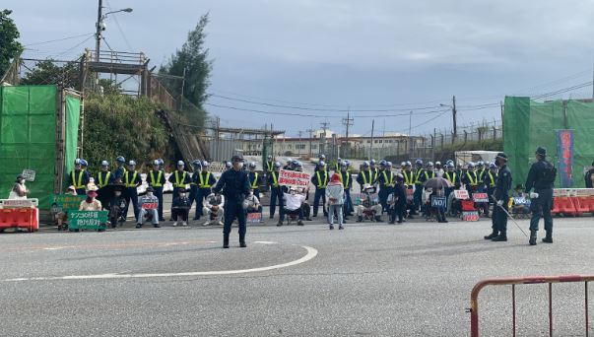***By Aviraj Gokool*

NOVEMBER 8, 2022

***By Aviraj Gokool***, ***Special from Okinawa***

Suzuyo Takazato, a Japanese politician, feminist and peace activist, leads a band of protestors opposing the relocation of the U.S. Marine Corps Air Station in Futenma every Wednesday.

Since July 2014, the 82 year old and her group have protested in every weather condition except during typhoons just outside the base of Camp Schwab in Henoko, Okinawa. This small community of social workers, nurses, and former teachers sing, chant, and block the entrance of Camp Schwab. Their peaceful protests have delayed military supplies from being delivered and prolonged the construction of the base while voicing their concerns.

“They might think that deploying soldiers might be helping our community or environment but actually, it’s really the cause of the problem,” Takazato said.

Since the construction of the first American base in April 1945, numerous issues have arisen in Okinawa about its adverse environmental impact. Sexual assault allegations involving military personnel have also set off alarm bells.

The bases have contaminated Okinawa’s drinking water with per- and polyfluoroalkyl substances ([PFAS](https://apjjf.org/2020/16/JMitchell.html)). If exposed, the substance causes harm to the body’s immune system and hormones and increases risk of cancer and cholesterol levels. Three main sources have been linked back to the military bases- firefighter training, aqueous film forming foam (AFFF) leaks, and disposal of AFFF. There are traces of PFAS in Okinawa’s water supply, exposing many Okinawans to the substance.

To harden Okinawa’s naturally soft seabed, constructors have been filling Henoko Bay with sturdy sediment which is polluting the water and harming the ocean life, more notably [the Dugongs](https://www.biologicaldiversity.org/species/mammals/Okinawa_dugong/), endangered Okinawan sea pigs, and [coral reefs](https://www.pref.okinawa.jp/site/chijiko/henoko/documents/summaryreport.pdf) that were untouched prior to the construction.

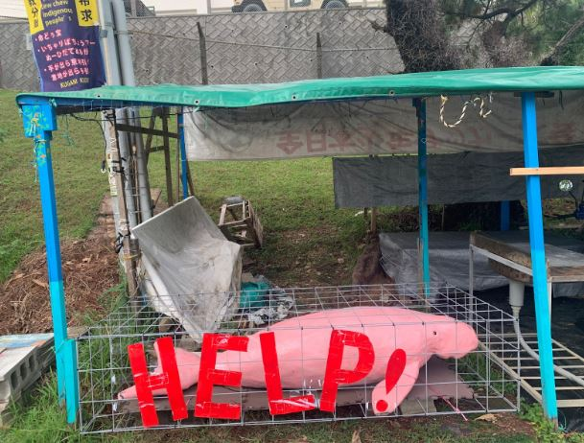*By Aviraj Gokool*

Okinawa has also been historically used as a testing ground for harmful products such as [Agent Orange](https://apjjf.org/2017/21/Mitchell.html), a chemical known to cause skin diseases, cancers, birth defects, and congenital malformations. American soldiers used the agent on the plants and grass to time how long it would take for effects to appear.

Along with environmental issues, residents in Futenma have reported [debris falling](https://www.asahi.com/ajw/articles/14717280) from the sky and destroying their rooftops. Rowdy military drills disturb residents across the island. Loud noise regularly comes from planes and helicopters constantly flying. There have been instances of helicopter and plane crashes on campuses and an elementary school; one in [1959](http://english.ryukyushimpo.jp/2019/07/05/30710/) where a jet crashed and killed 18 people. Another [occurred in 2016](https://www.asahi.com/ajw/articles/13059072) when an [Osprey crashed](https://www.asahi.com/ajw/articles/13059072) off the coast of Abu, Nago City.

Many victims of sexual assault turn to Takazato for guidance and assistance. Takazato is exposed to many sexual violence stories and is working on the 13th edition of a sexual violence chronology. She shared some of her findings of American military men that have [sexually assaulted](https://asamnews.com/Users/AsAmNews1/Downloads/admin,+cws19n4_takazato.pdf) local girls. She explained in the 1950s a U.S. soldier kidnapped and raped a [9-month-old baby](https://www.japantimes.co.jp/news/2021/03/18/national/social-issues/okinawa-women-military-violence/) with no repercussions. A few years later in 1955, another U.S. soldier kidnapped, raped, and murdered a 6-year-old child. He disposed of her body in a landfill area.

Initially the soldier was sentenced to the death penalty, but over time the court reduced his sentence, and eventually, he was freed.

“We feel how we are treated by the US government. How we are seen by the US government. Or by American people,” Takazato said.

Takazato and Okinawan people were outraged because they felt disrespected, and ignored, and the incident seemed forgotten.

“My concern, why I’m standing here, is to reduce any single base. To reduce the base means the number of soldiers, reduce the number of training. The new base really enforces all these incidents, the accidents, and the rape cases,” Takazato said.

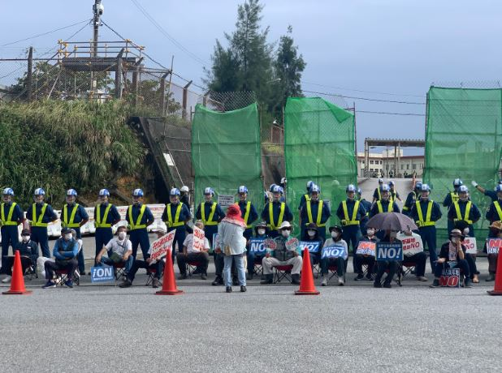*By Aviraj Gokool*

A majority of the island is against the relocation and the existence of military bases, there are a handful of people in Henoko who are not opposed to the relocation. People see there are some merits the bases bring to the island.

Genya Tsue, an employee at a Henoko tattoo parlor in his early 20s, goes to a nearby college and has befriended military personnel. He works with an American tattoo artist and has much exposure to American soldiers.

“[The base] is breaking the environment, the purpose of bases is to invade other countries or to kill people and I don’t like that. But, there are many Okinawan employers working in bases, so it’s good for the economy.”

Tsue pointed out that many of the businesses, including the tattoo parlor, exist and attract more customers because of the bases and increased population it brings.

Some people in Naha — the capital of Okinawa — feel that Henoko is too far of a city for them to worry about. On the other hand, much of the younger generation seems to have no concrete opinion on the decision.

Jeff Kingston — an author and professor from Temple University who has researched much of Japan’s social issues— is critical of the presence of the base. However, he has also interviewed some who opposed the base. He writes in [Global East Asia](https://www.degruyter.com/document/doi/10.1525/9780520971424-003/html?lang=en), “Okinawa has the highest unemployment and lowest per capita income in Japan, so the somewhat higher wages (two hundred to three hundred yen higher per hour) on the bases are appreciated.”

Two college students — Risa Shimoji and Saiya Taira — in Naha who volunteered at the 2022 Uchinanchu Festival have also expressed their perspective.

“For me, I think it’s fine if [the base] was relocated, but to be honest, I would be very content if things like runoff contamination in the water, objects falling, those types of things did not happen,” said Shimoji.

Building off of Shimoji, Taira went into more detail on how she thinks the relocation could be better for the Ginowan people, but not the island.

“I think that from the point of view of the people of Ginowan, the relocation of the base from Futenma to Henoko will reduce plane accidents, crashes, or any other dangerous noise. However, although those things may be an advantage, it is said if they try to move the base to Henoko, Dugongs and coral reefs will get dirtied, which is a disadvantage. There are both advantages and disadvantages but we need to think about whether we are going to give priority to the environment and human lives. I am thinking about it but I have not decided whether I think it is a good idea for the base to be relocated to Henoko,” said Taira.

70.6% of American military bases are located on [Okinawa](https://dc-office.org/basedata), which is 0.6% of Japan’s land. The number of bases and personnel only seems to be increasing. Okinawa holds much of the burden of harboring American bases and has been fighting against militarism for almost 50 years.

***(Correction: An earlier version of this story may have given the incorrection impression that Jeff Kingston supports the presence of the US base. We regret the error.)***